**CSA07** - **Computer Network Experiments Output Images**

1) Configuration of Network Devices using Packet Tracer tools (Hub, Switch, Ethernet, Broadcast) 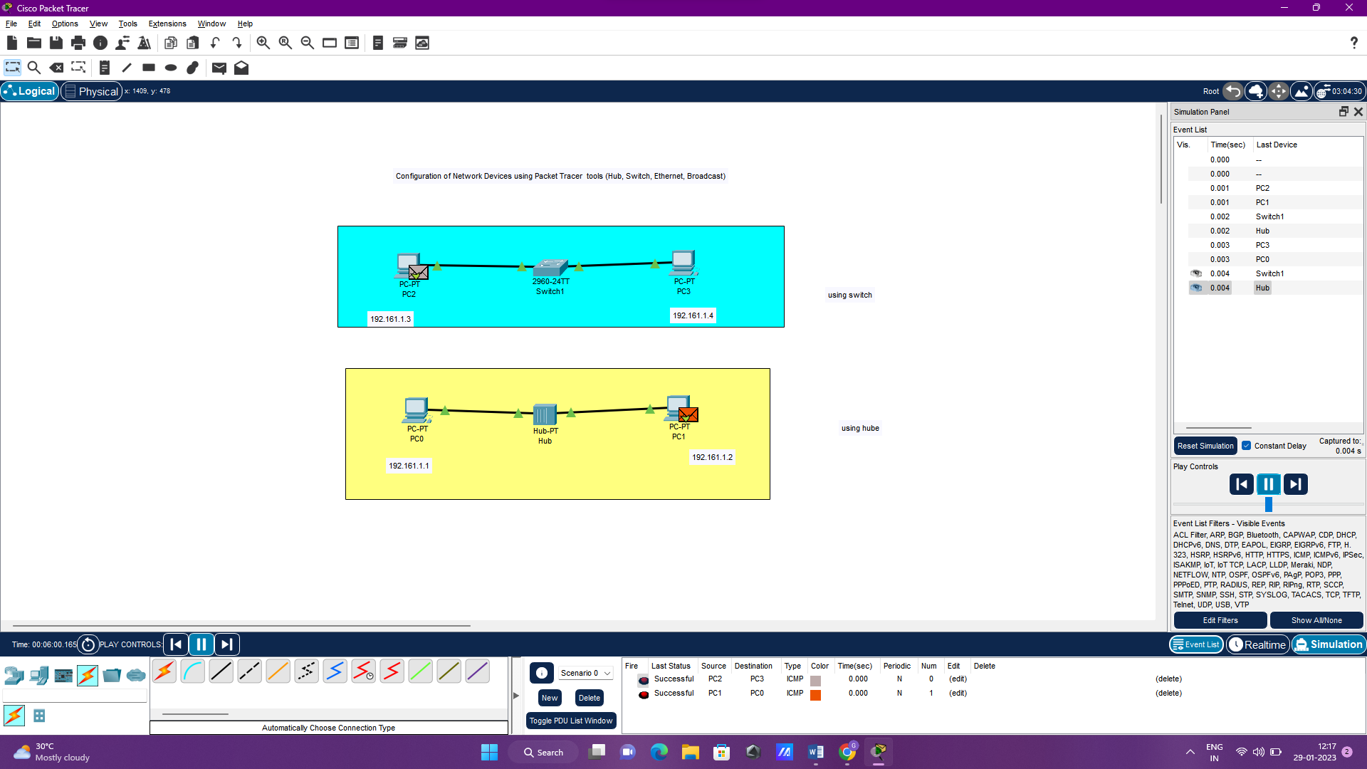

2) Design and Configuration of Star Topologies using Packet Tracer

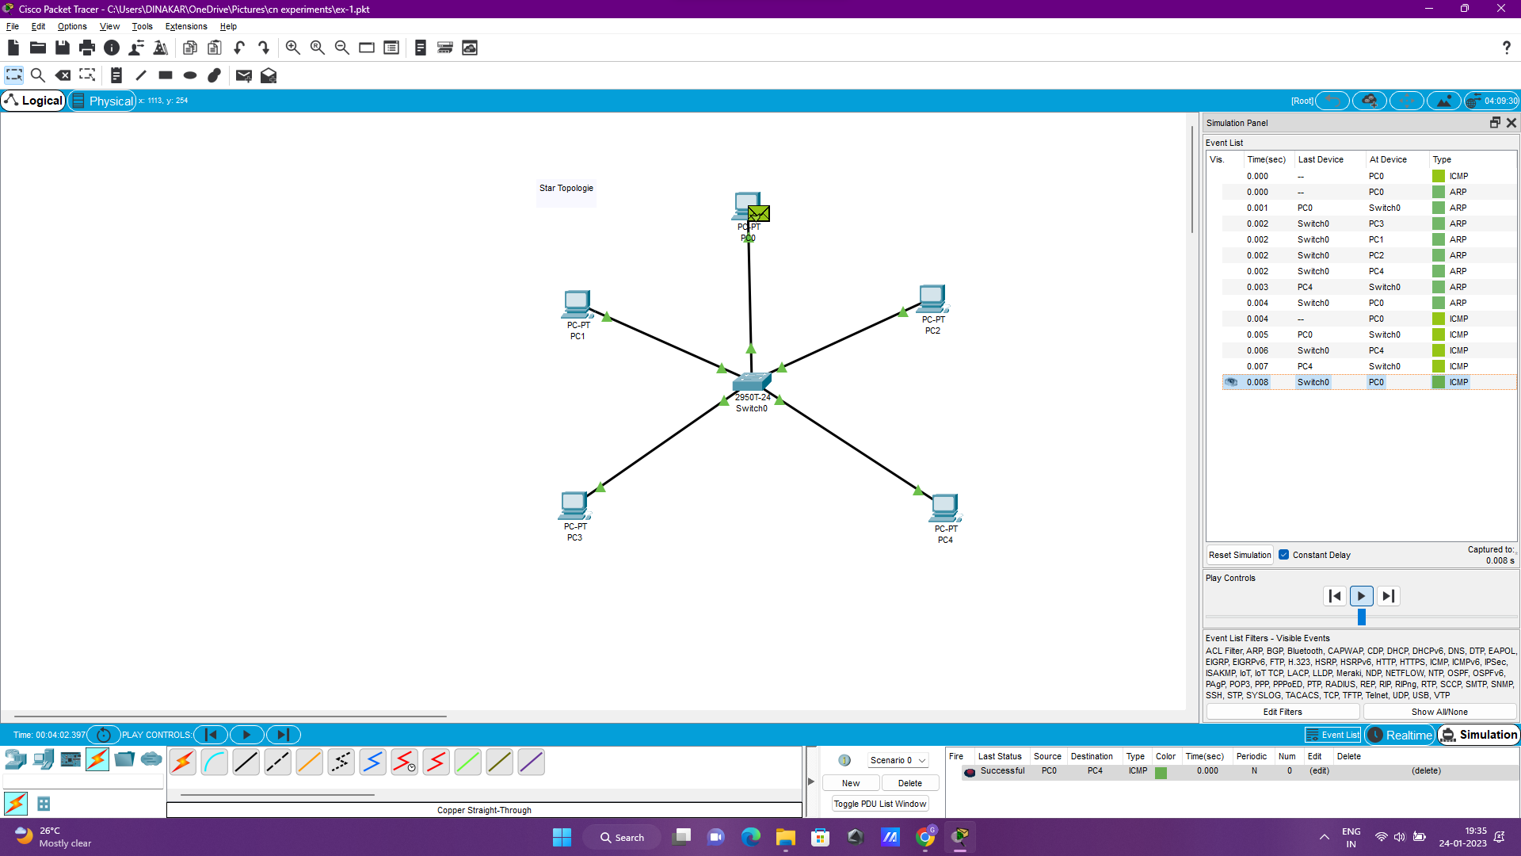

3) Design and Configuration of BUS Topologies using Packet Tracer

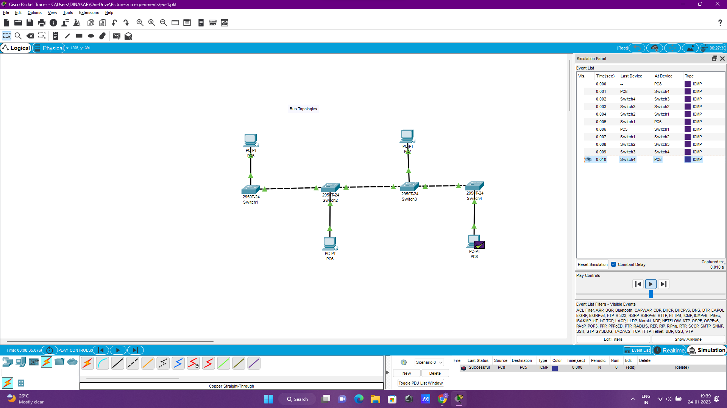

4) Design and Configuration of RING Topologies using Packet Tracer

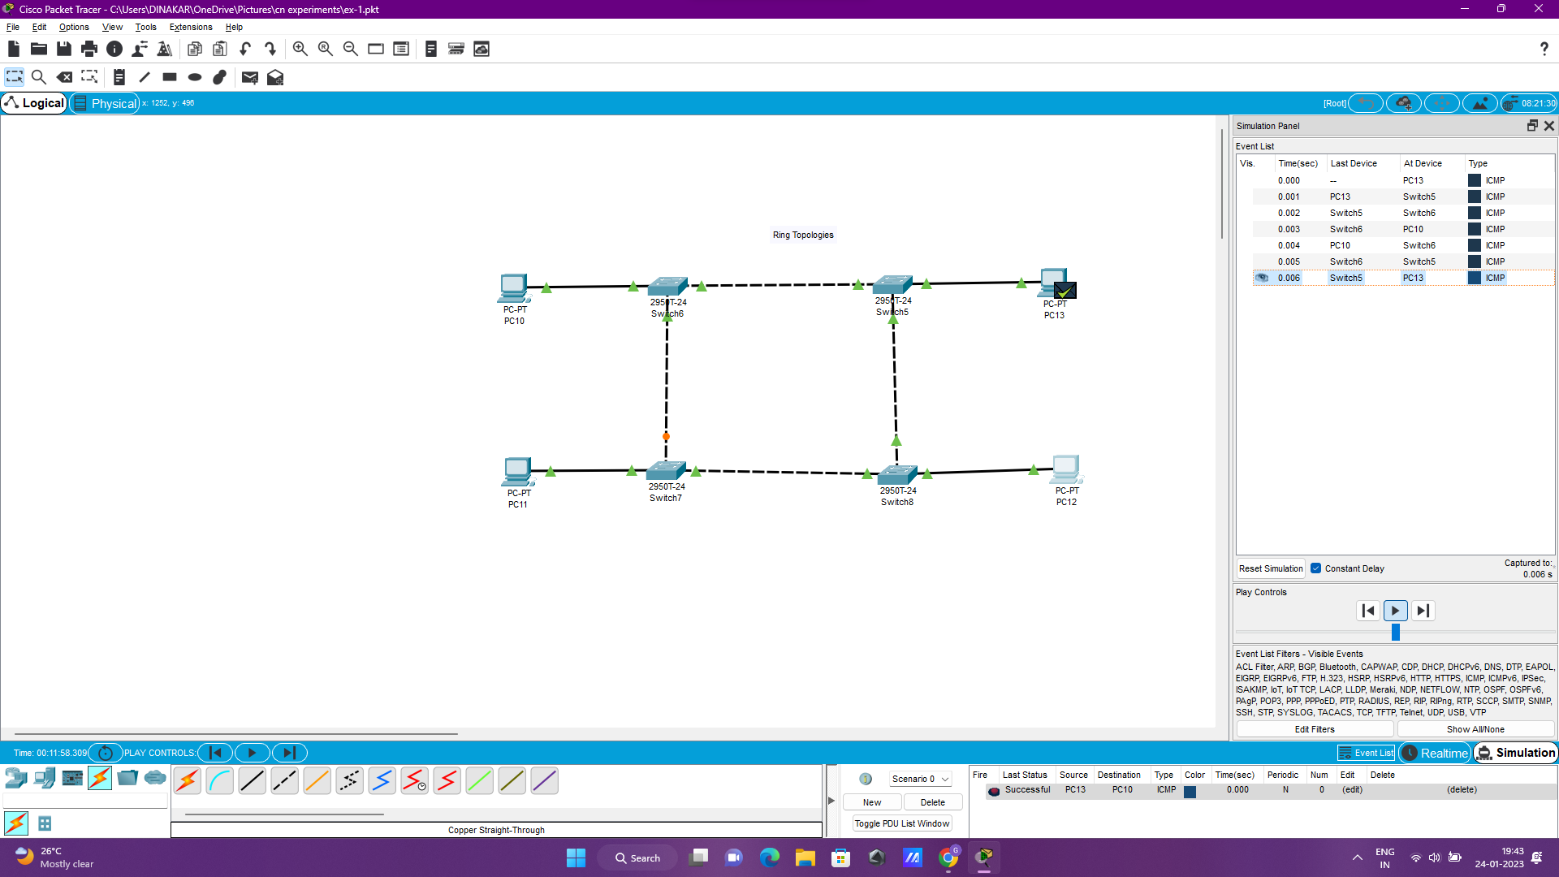

5) Design and Configuration of Mesh Topologies using Packet Tracer

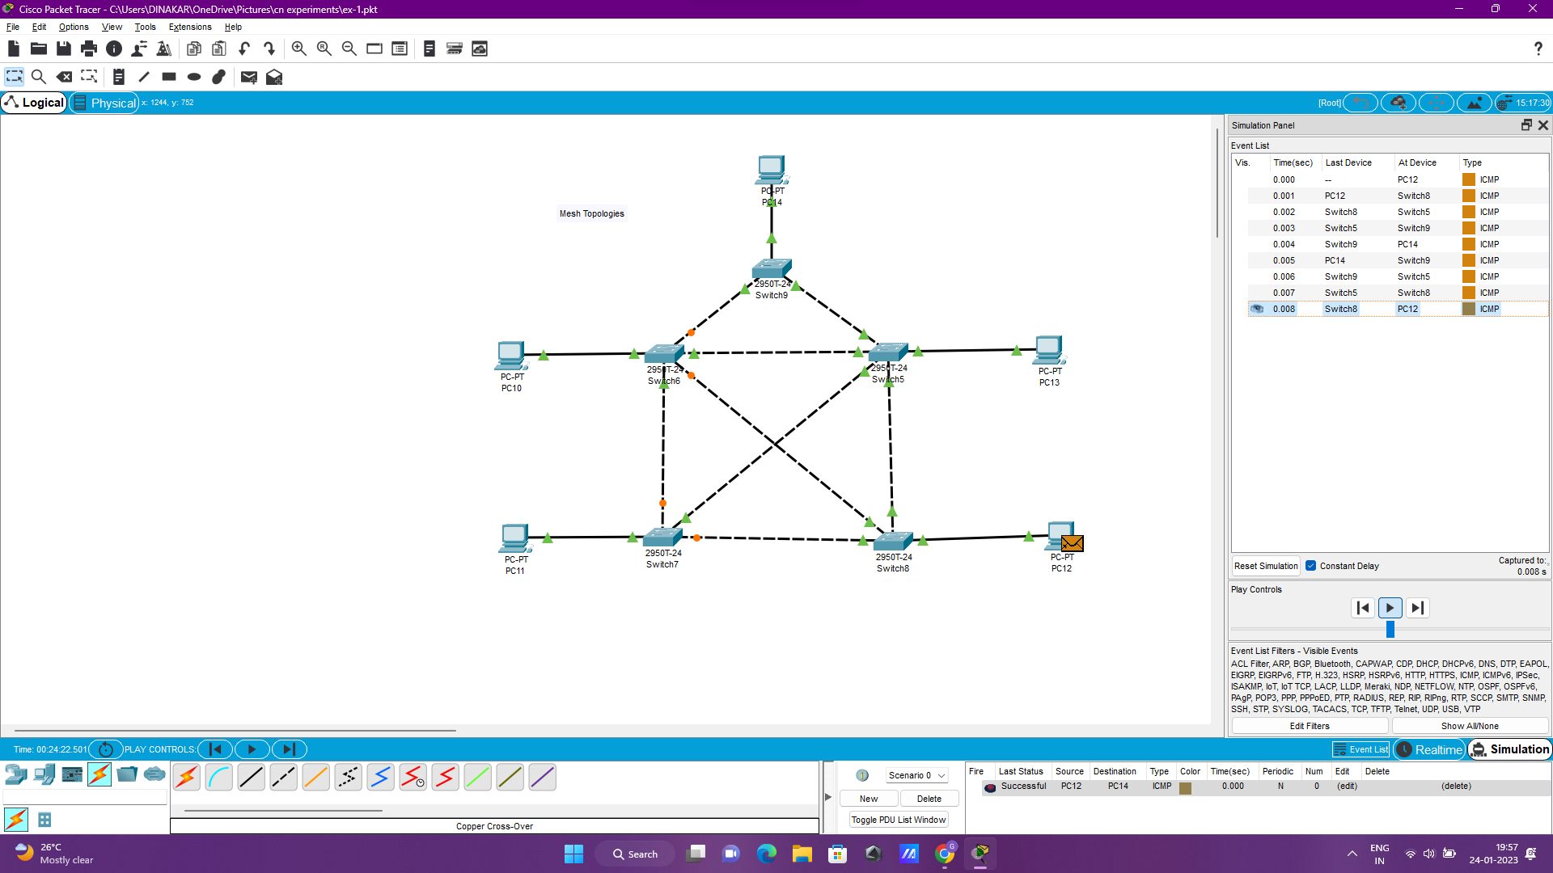

6) Design and Configuration of Tree Topologies using Packet Tracer

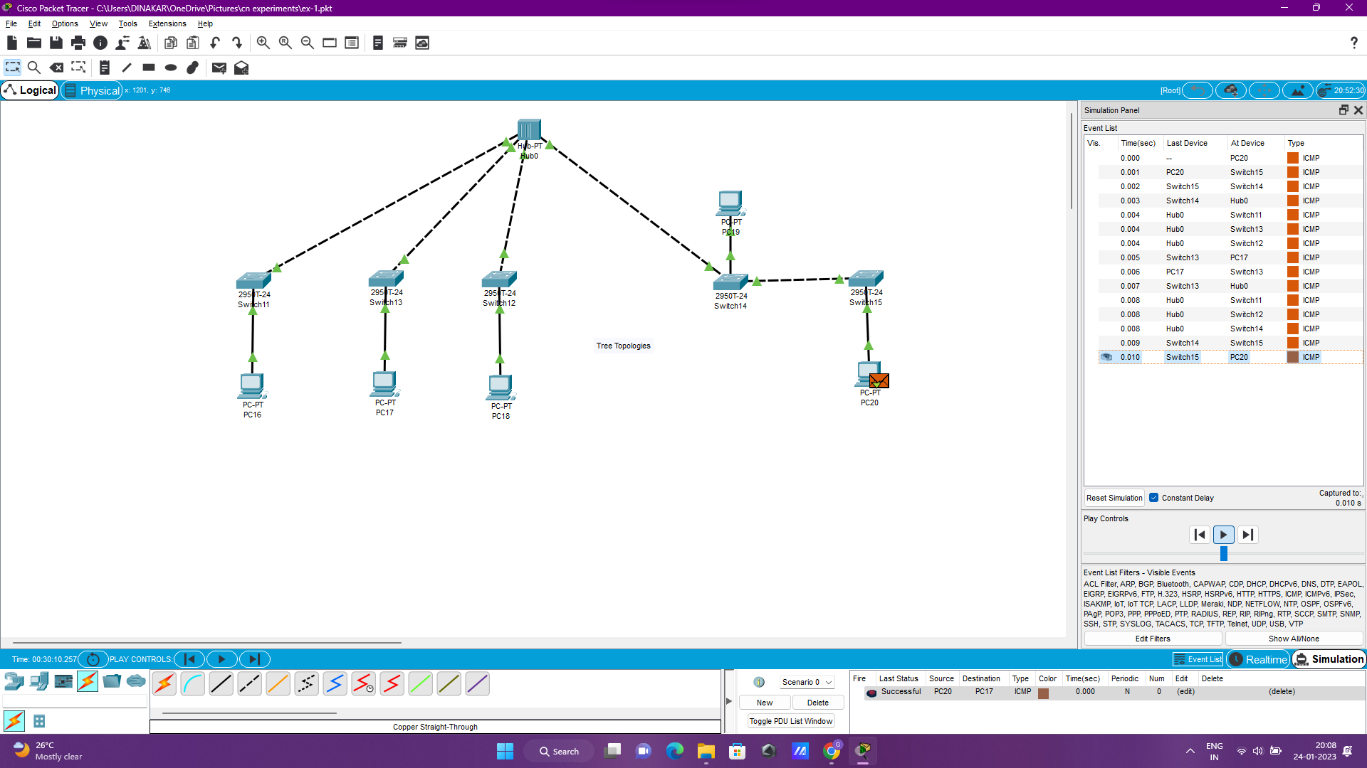

7) Design and Configuration of Hybrid Topologies using Packet Tracer

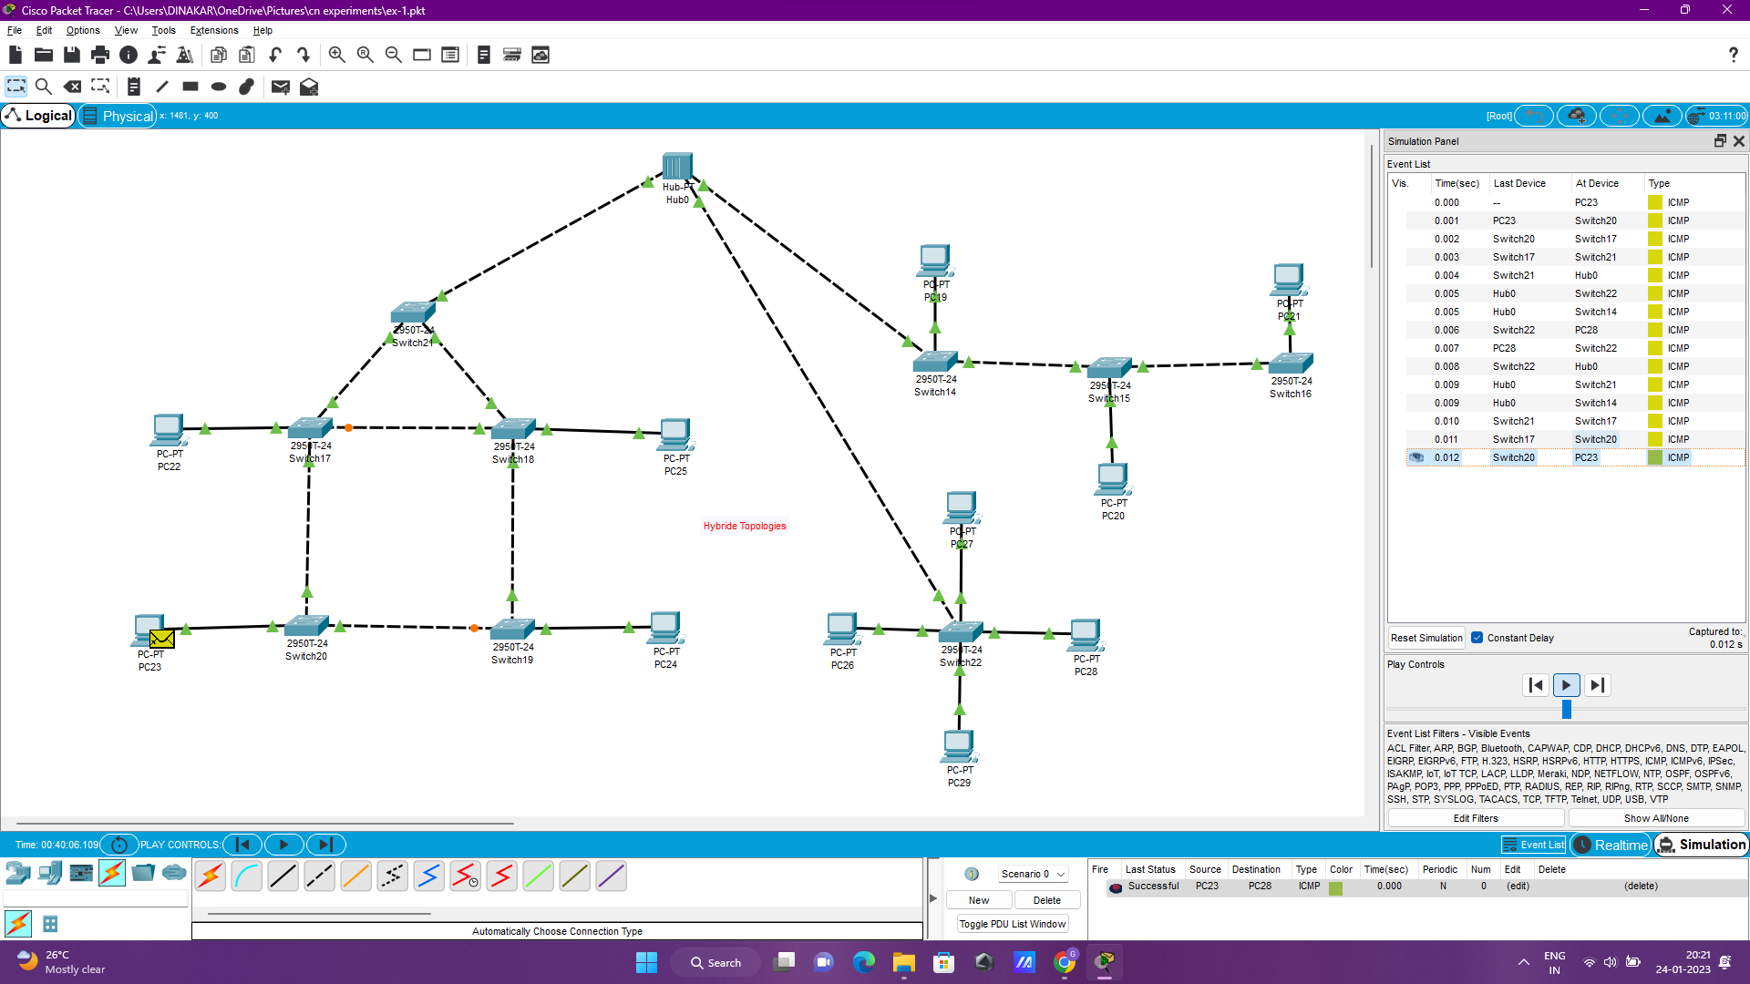

8) Data Link Layer Traffic Simulation using Packet Tracer Analysis of ARP

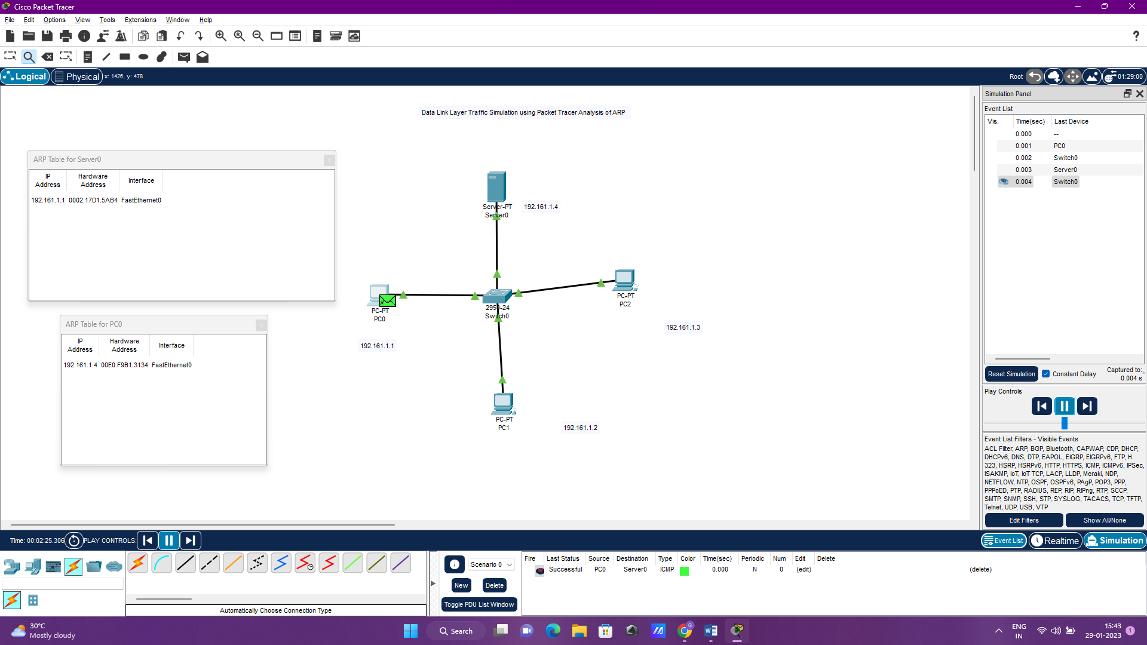

9) Data Link Layer Traffic Simulation using Packet Tracer Analysis of LLDP

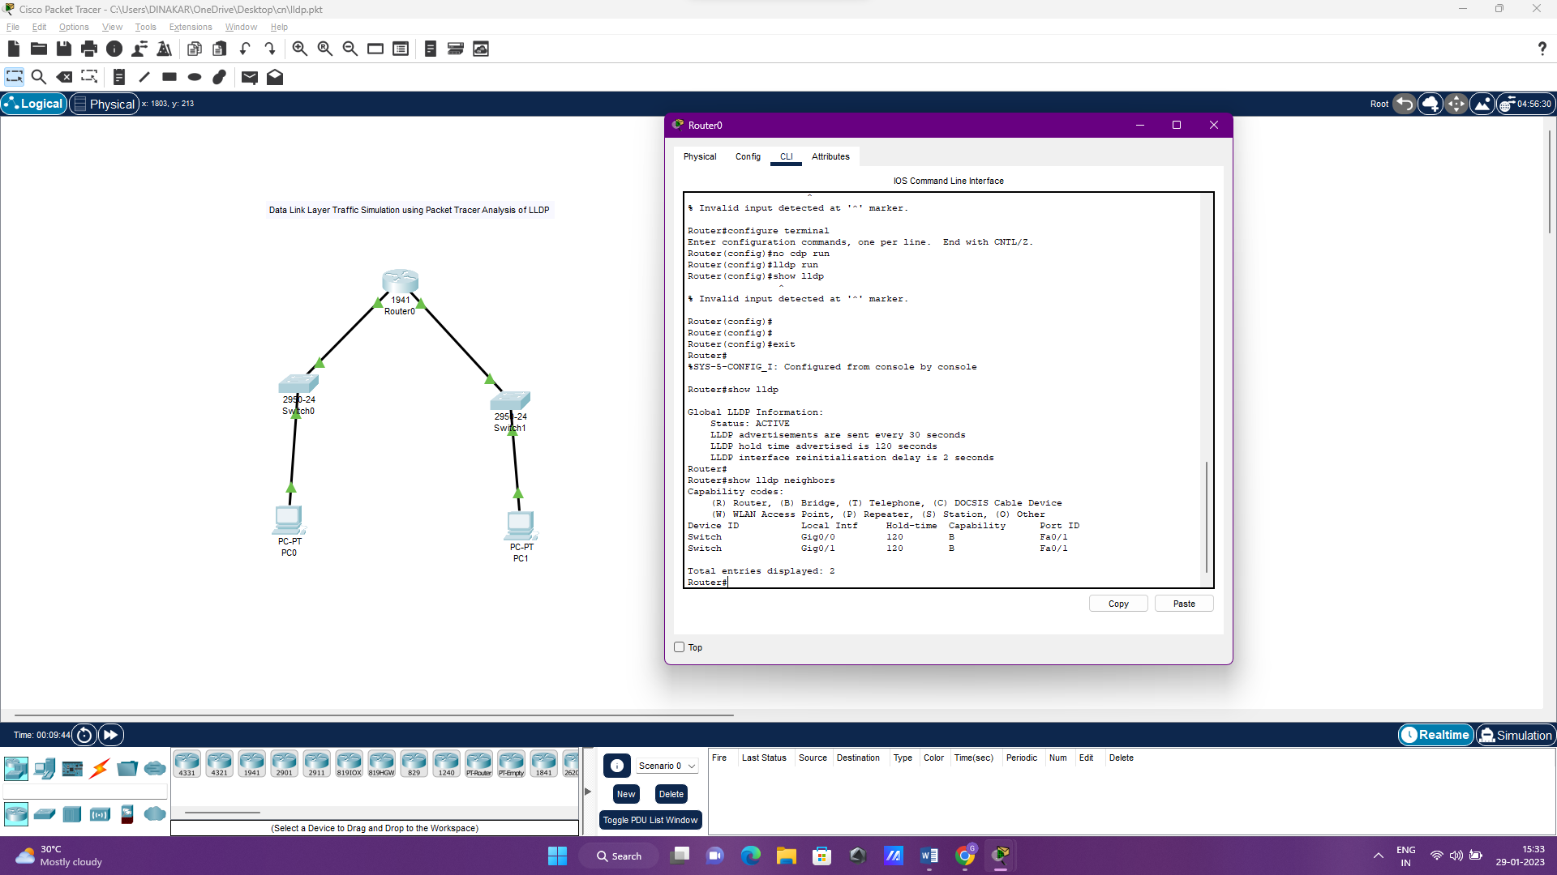

10) Data Link Layer Traffic Simulation using Packet Tracer Analysis of CSMA/CD & CSMA/CA

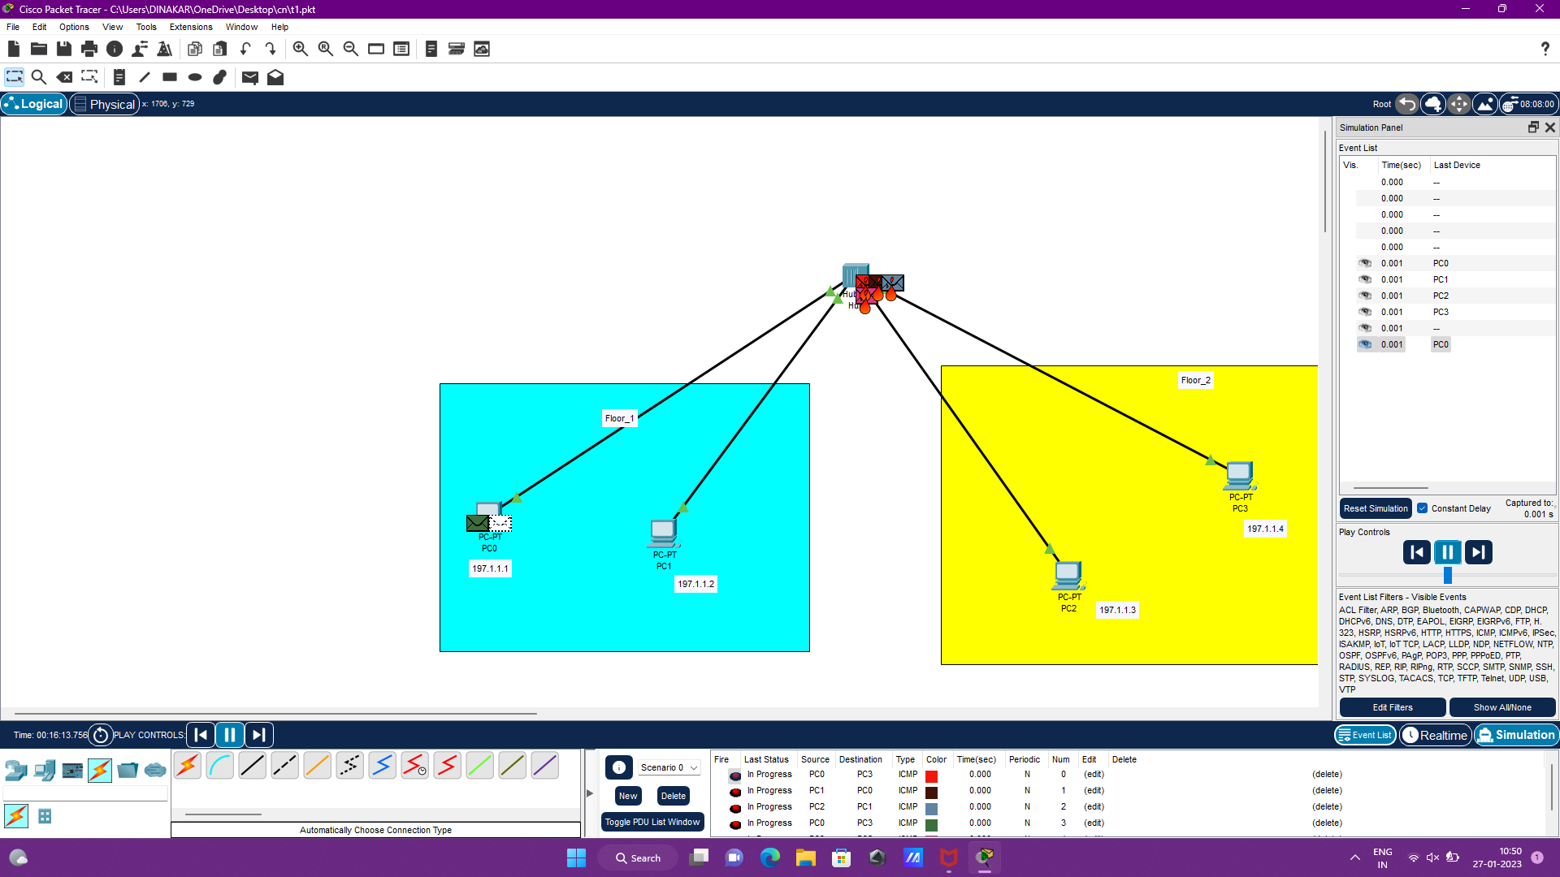

11) Implementation of Bit stuffing mechanism using C

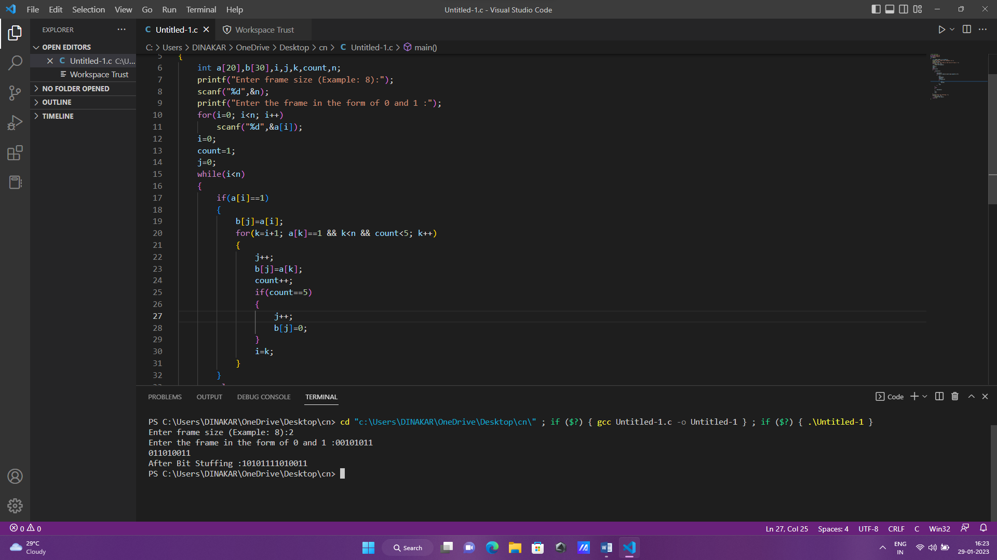

12) To design the two different network with Static Routing techniques using

Packet Tracer

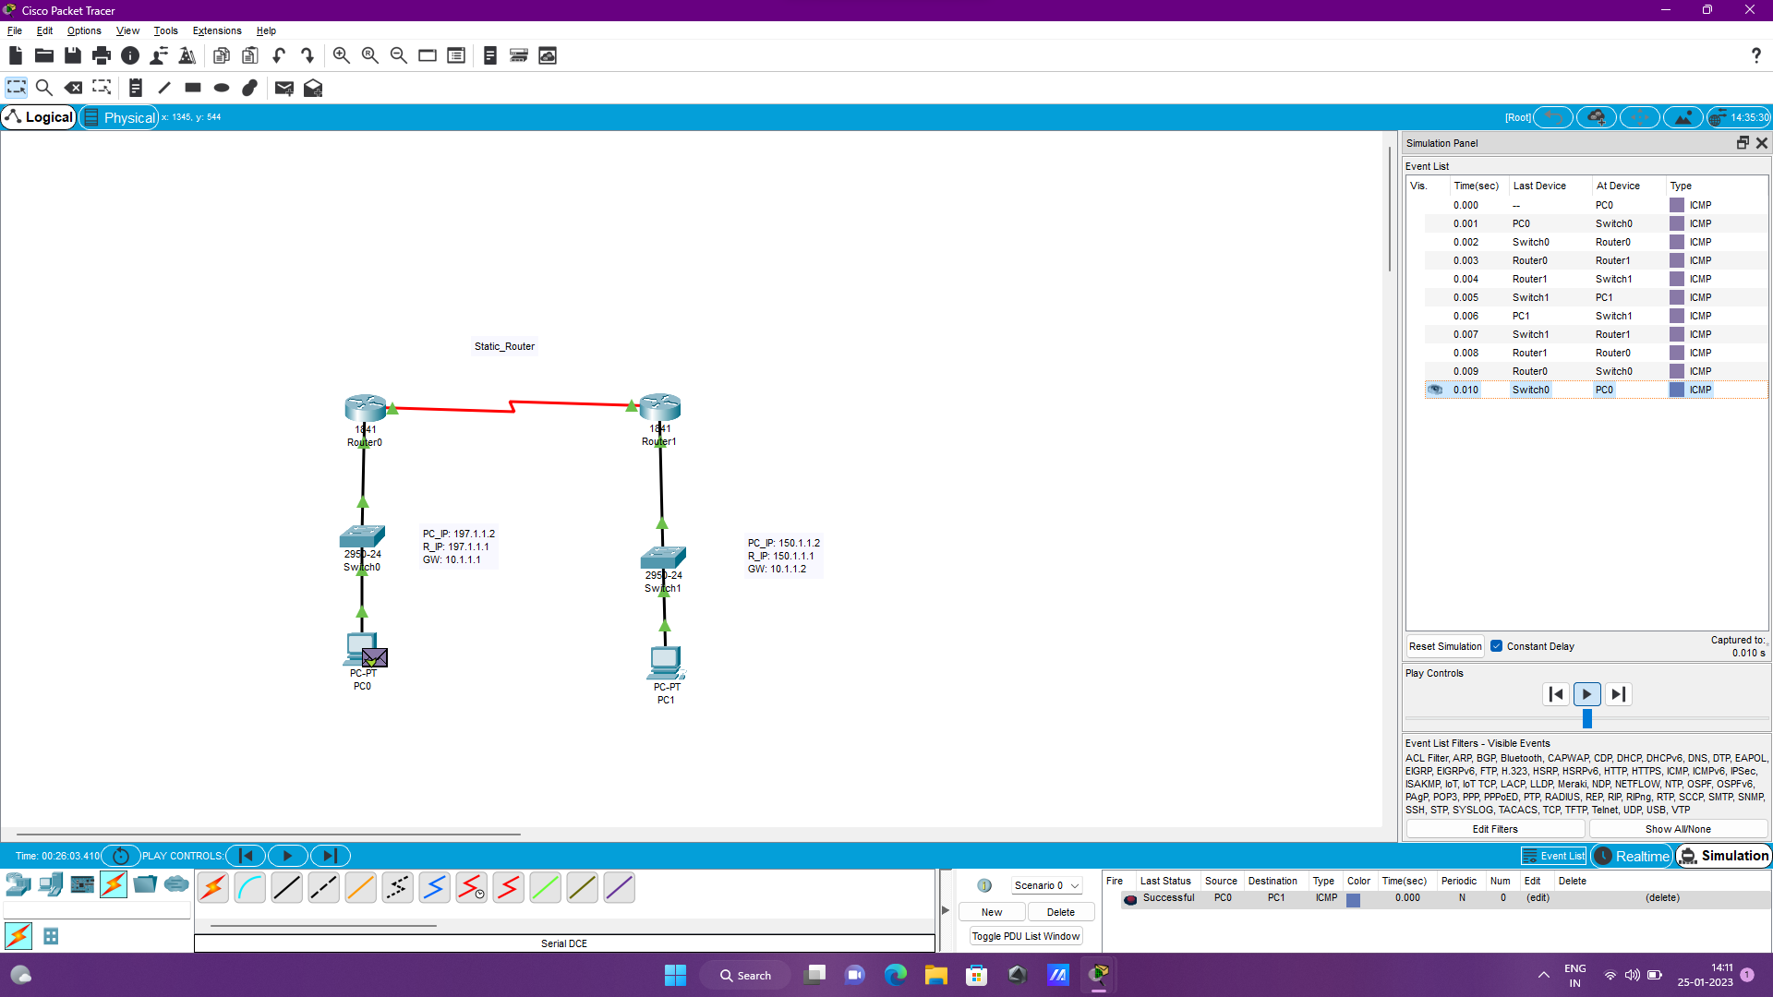

13) To design the Network with Dynamic Routing using Packet Tracer (Distance vector & OSPF)

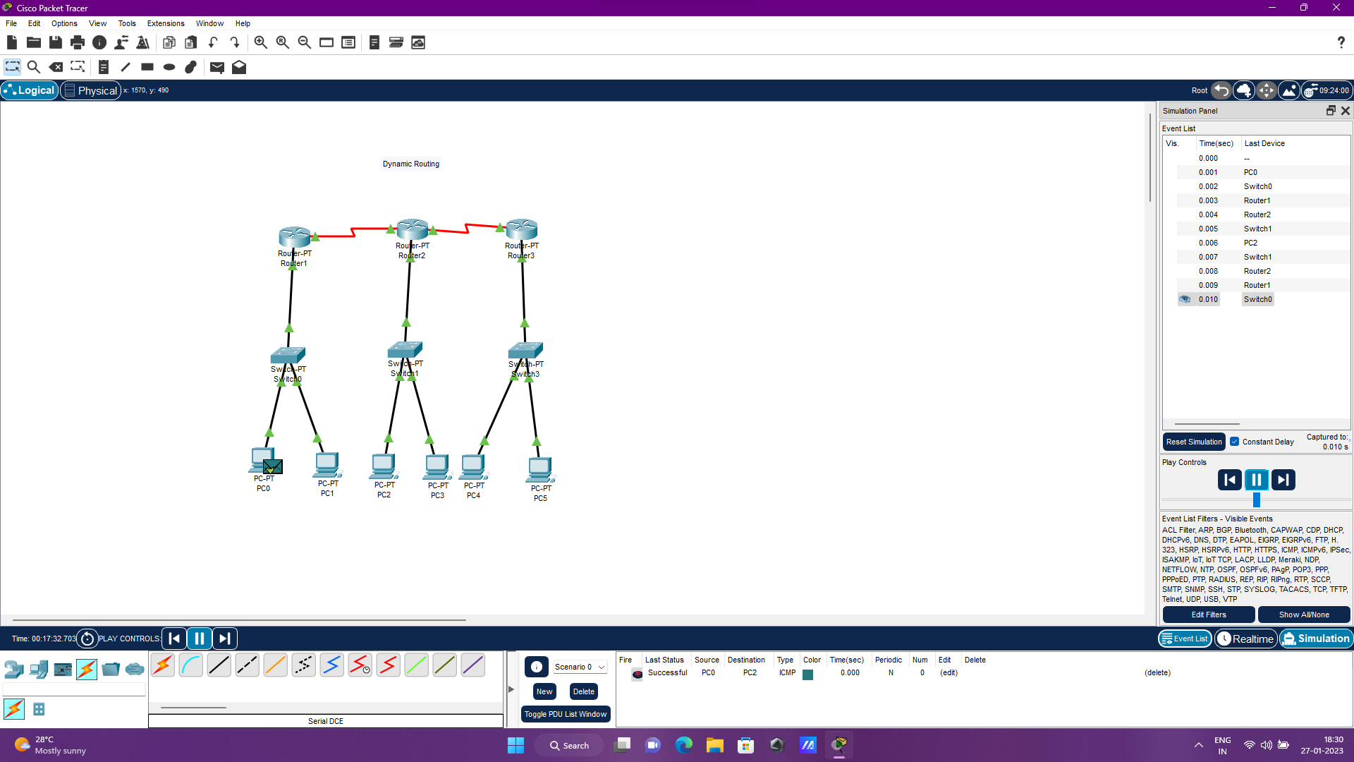

14) Design the Functionalities and Exploration of TCP using Packet Tracer

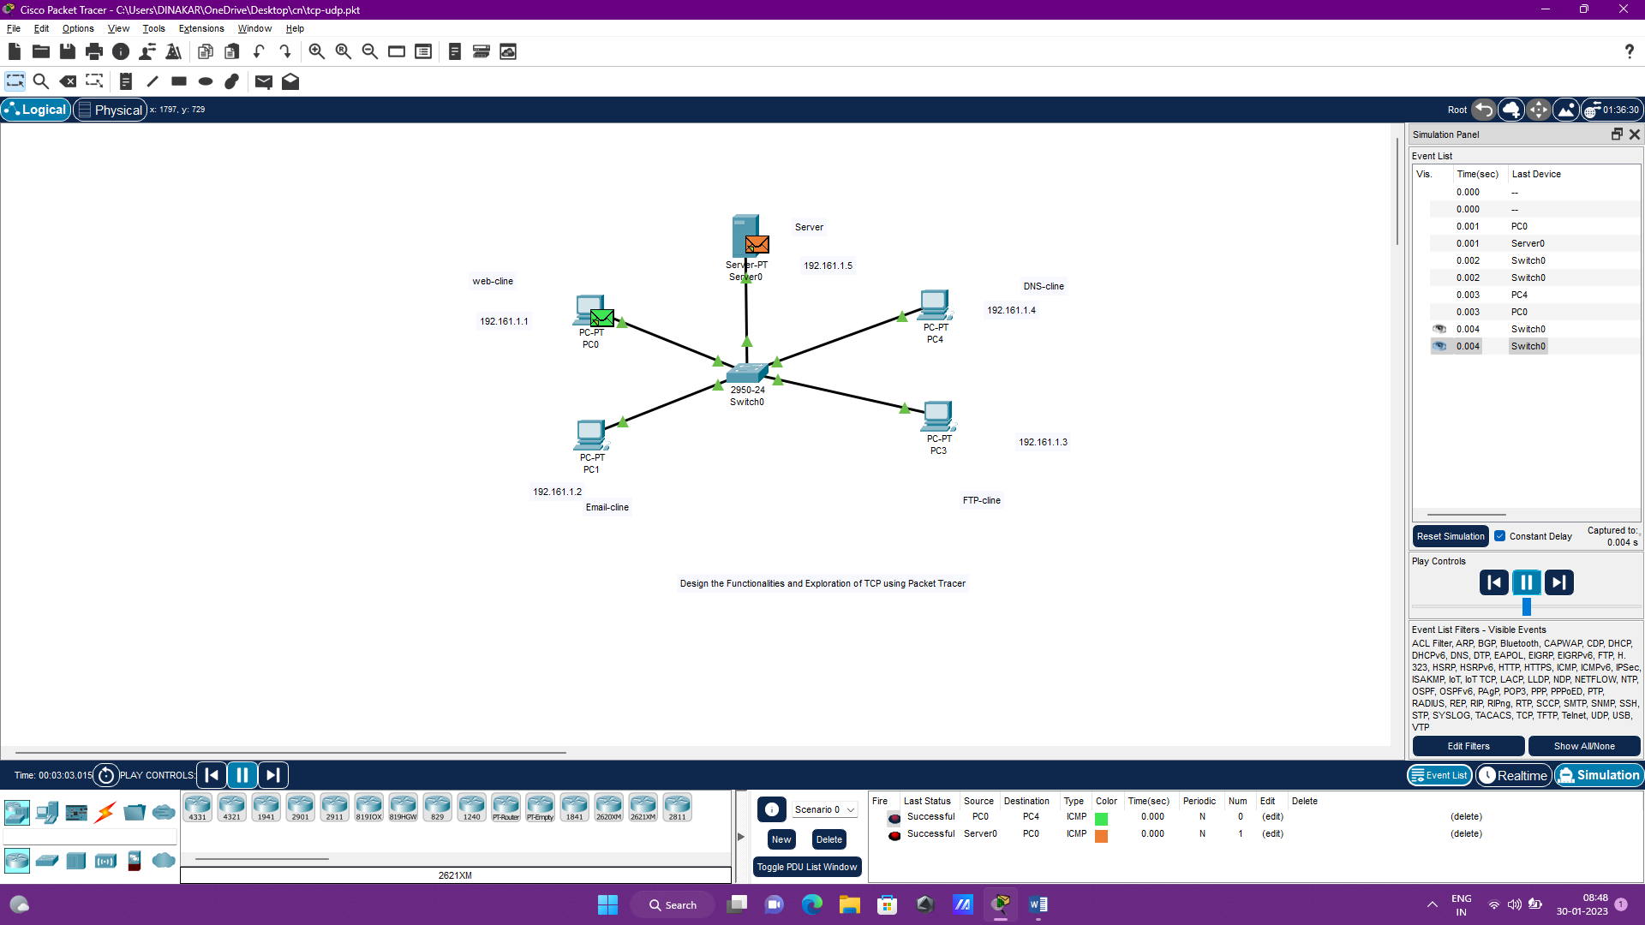

15) Design the Functionalities of Exploration UDP using Packet Tracer

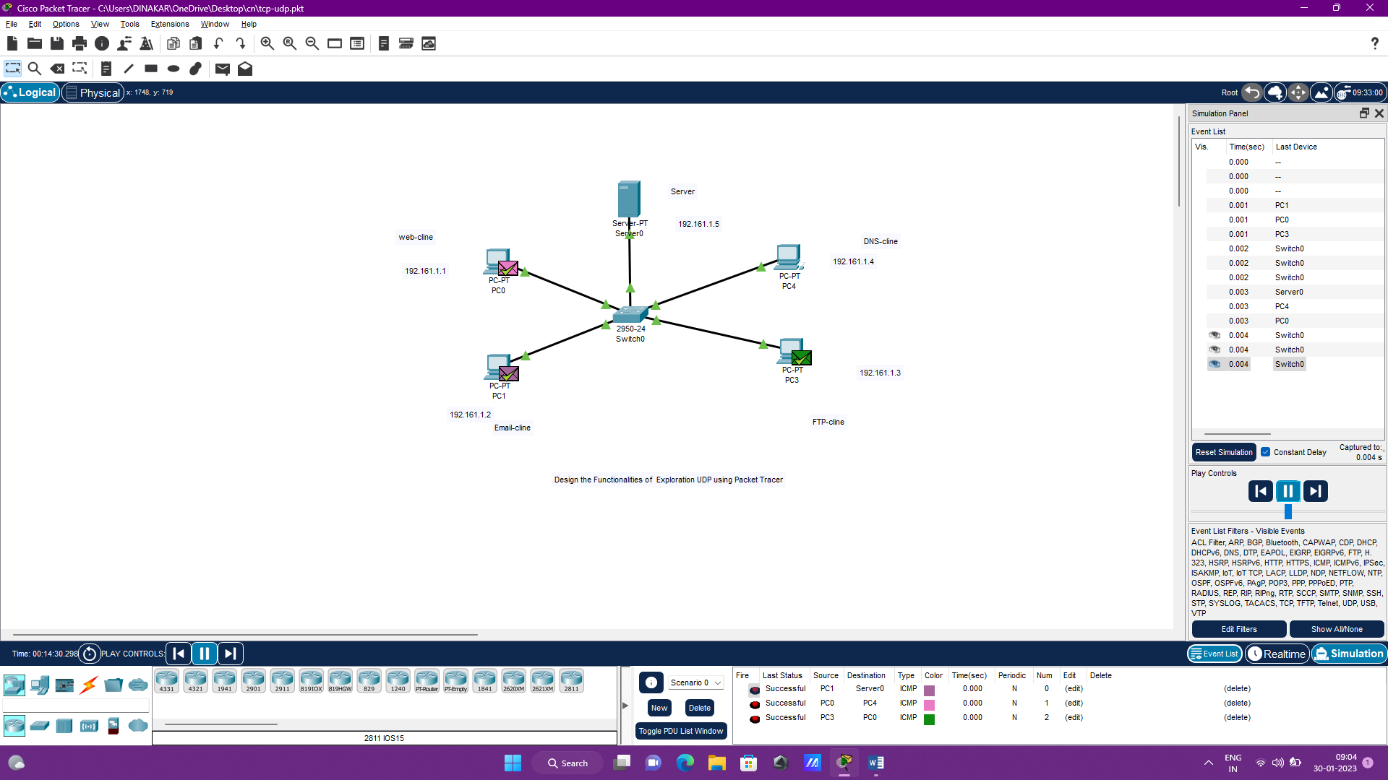

16) Design the network model for Subnetting – Class C Addressing using packet tracer

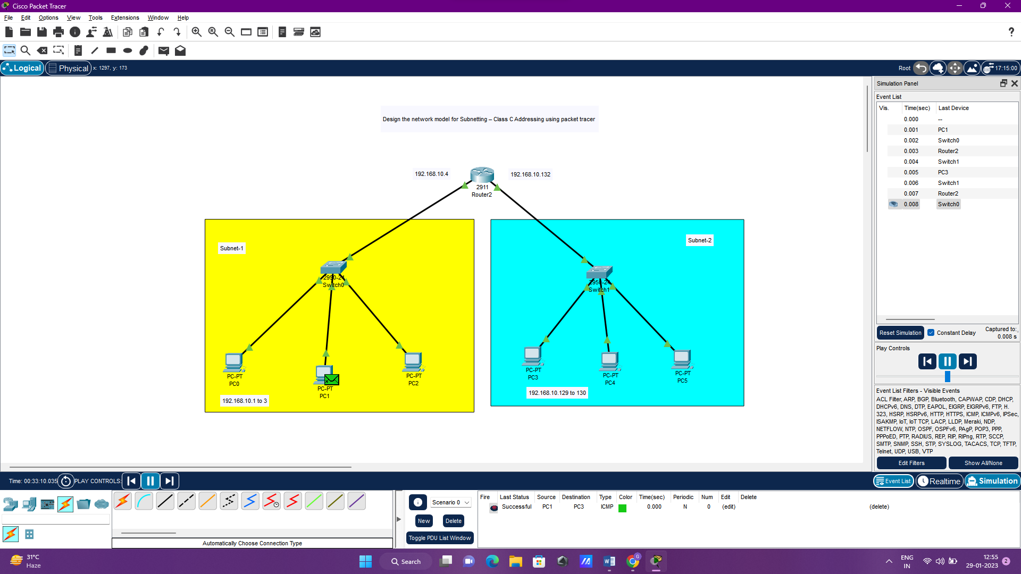

17) Implementation of server – client using TCP socket programming

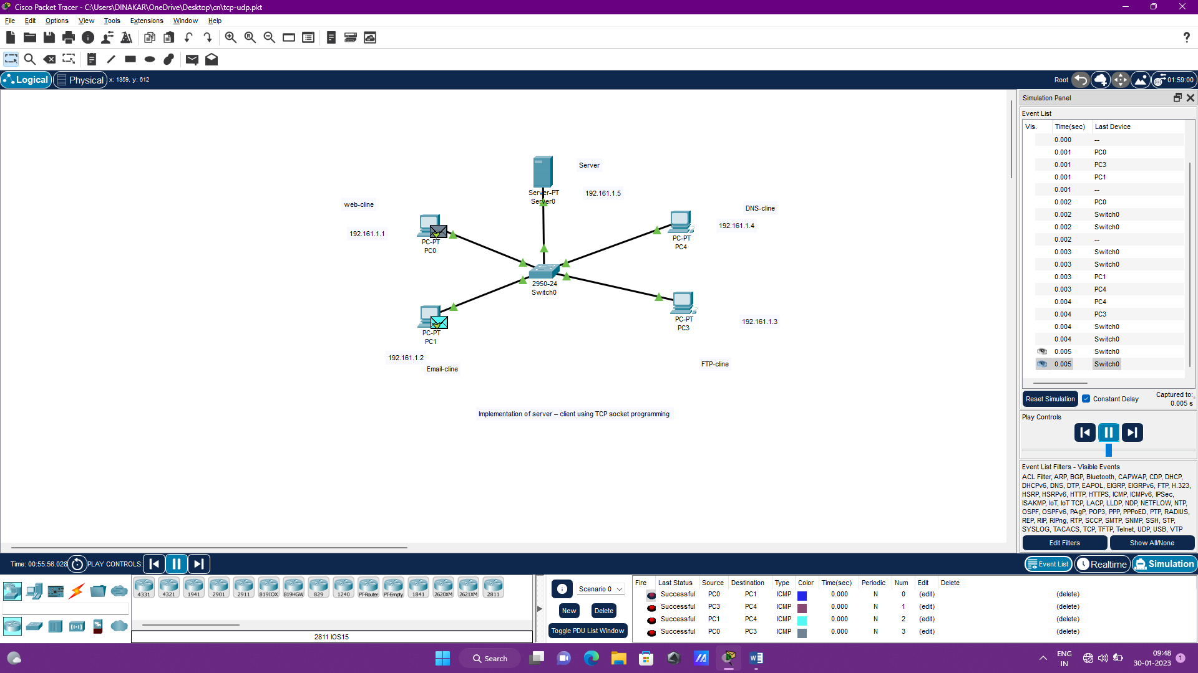

18) Implementation of server – client using UDP socket programming

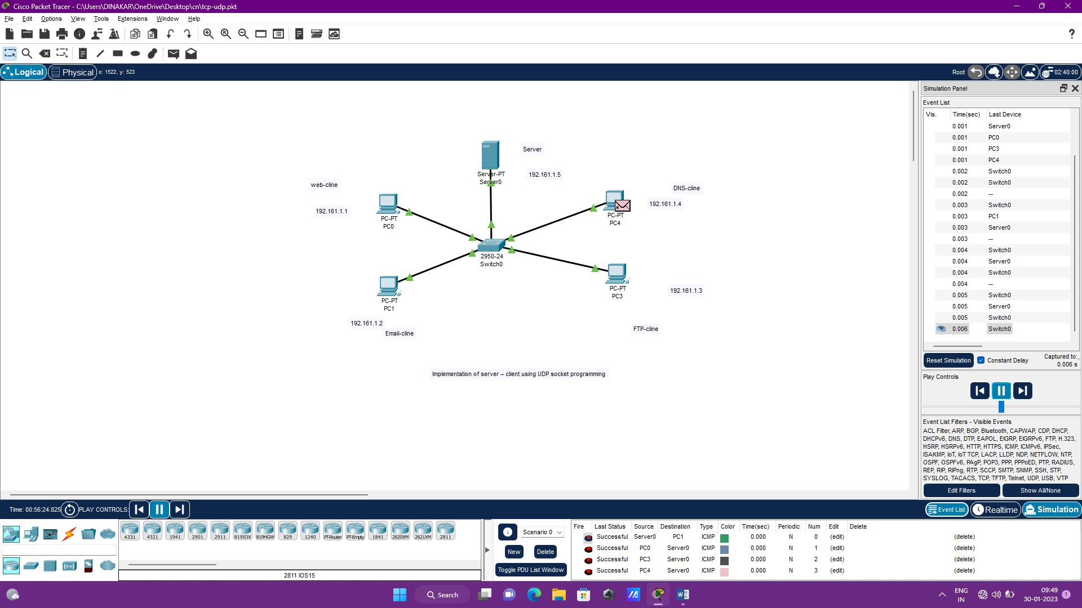

19) Simulating X, Y, Z Company Network Design and simulate using Packet Tracer

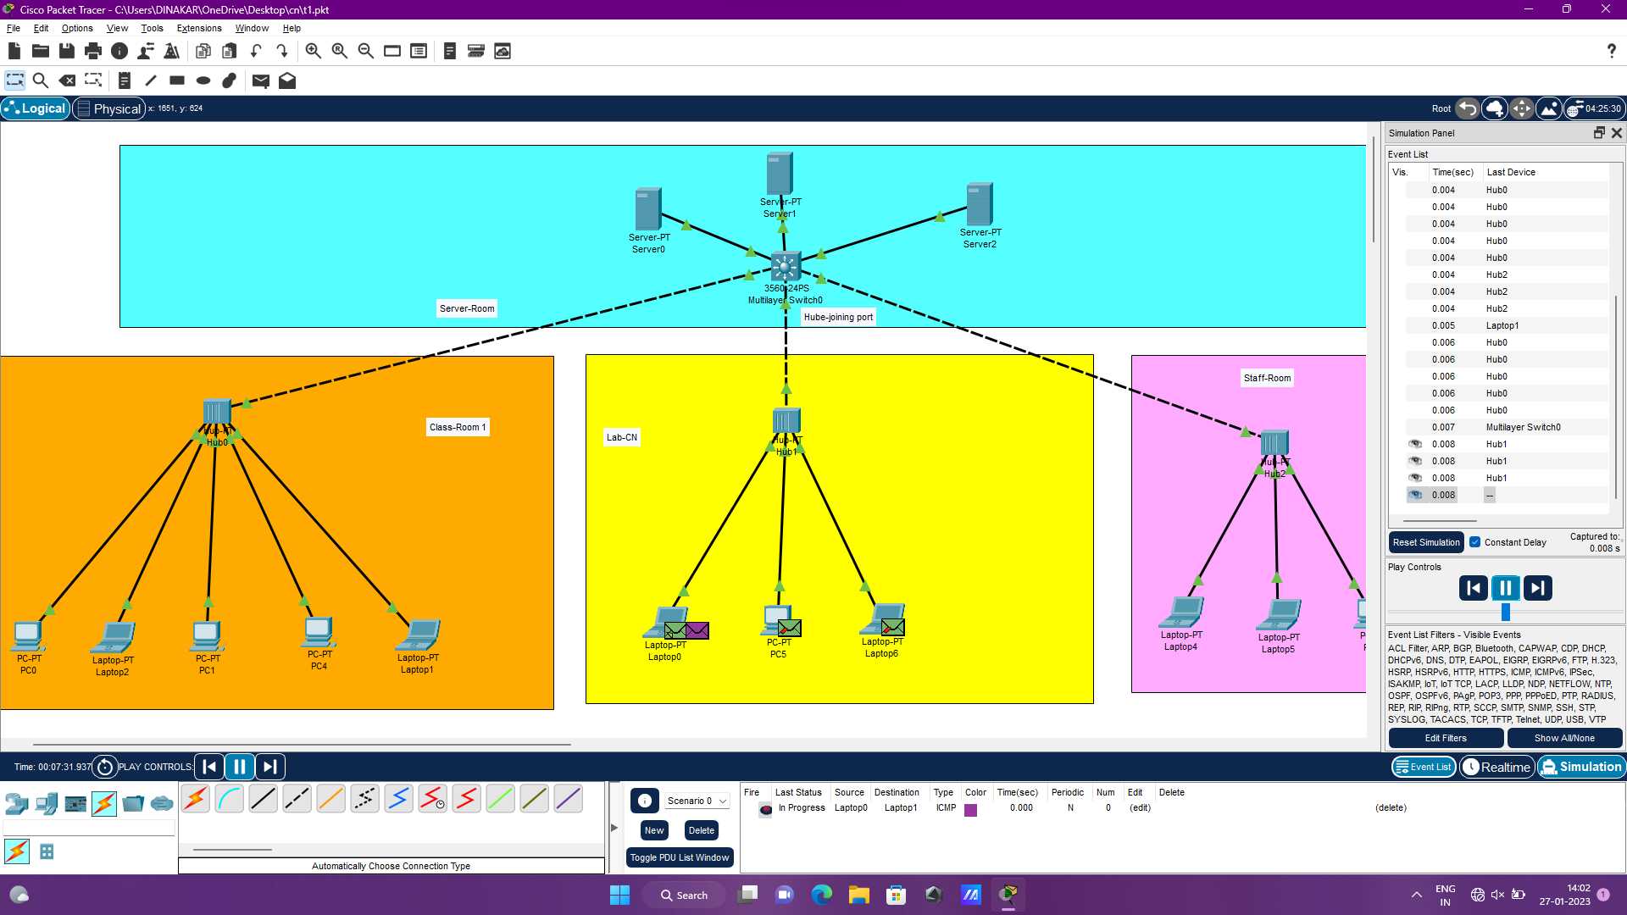

20) Configuration of DHCP (dynamic host configuration protocol) in packet tracer

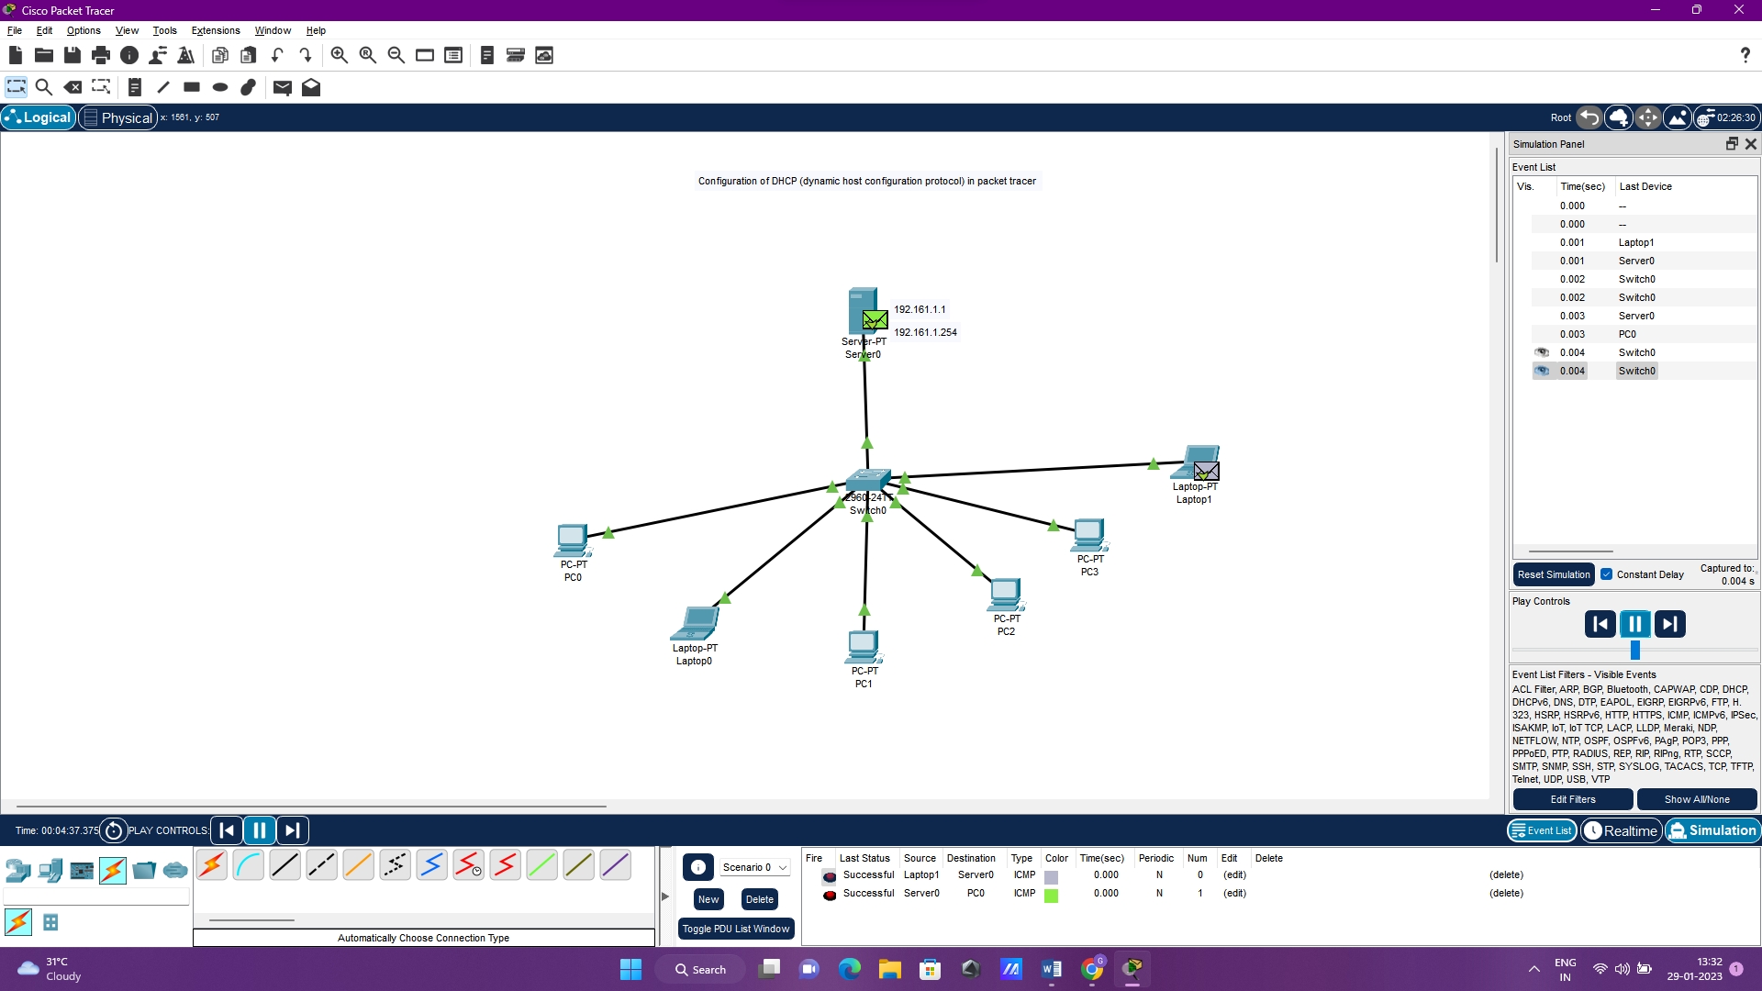

21) Configuration of firewall in packet tracer.

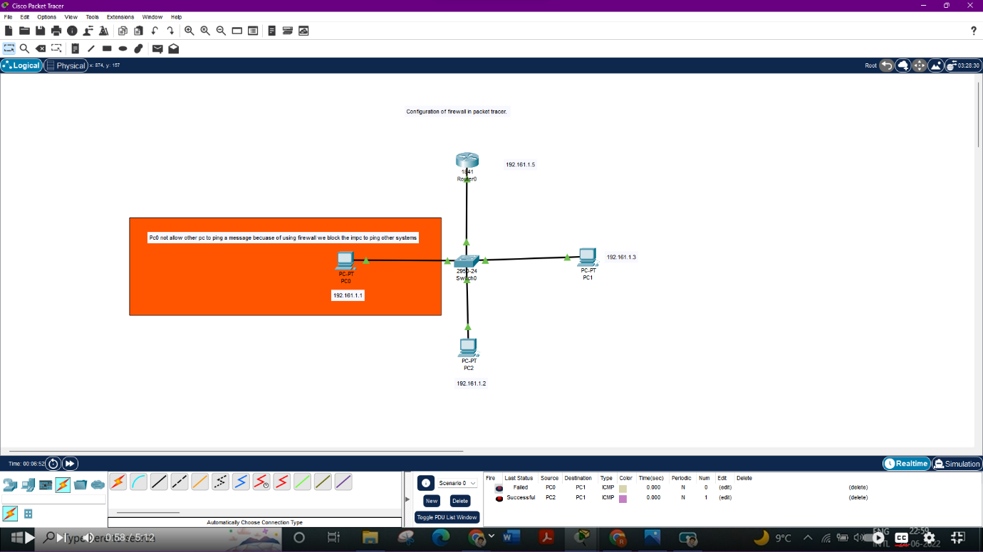

22) Make a Computer Lab to transfer a message from one node to another to design and simulate using Cisco Packet Tracer

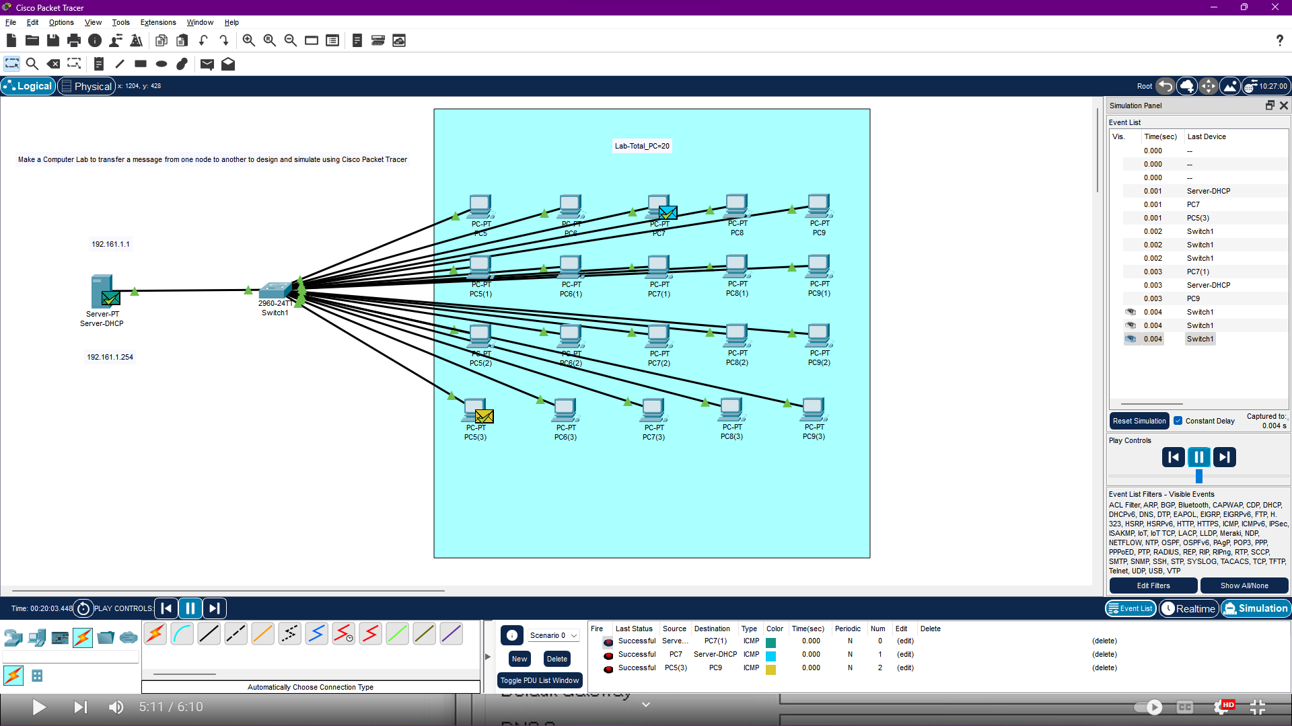

23) Transport layer protocol header analysis using Wireshark- TCP

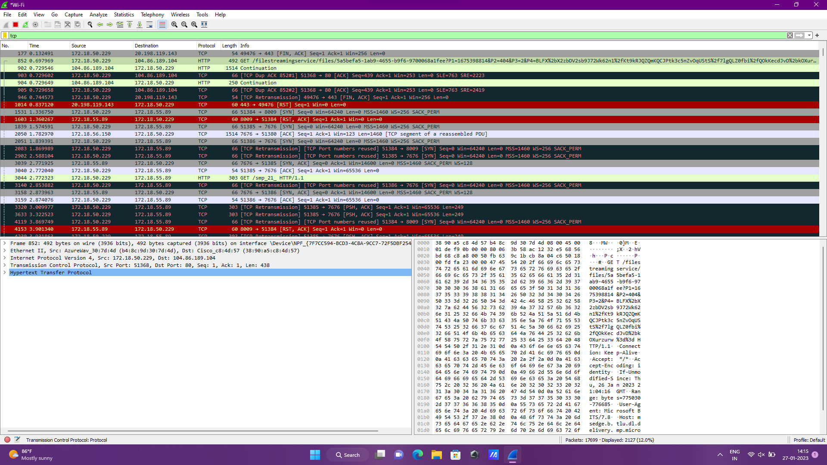

24) Network layer protocol header analysis using Wireshark - SMTP

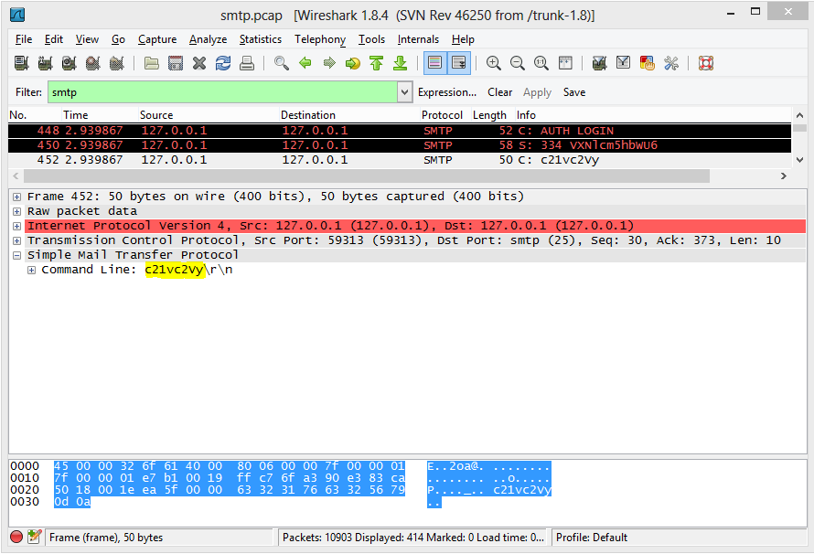

25) Network layer protocol header analysis using Wireshark - ICMP

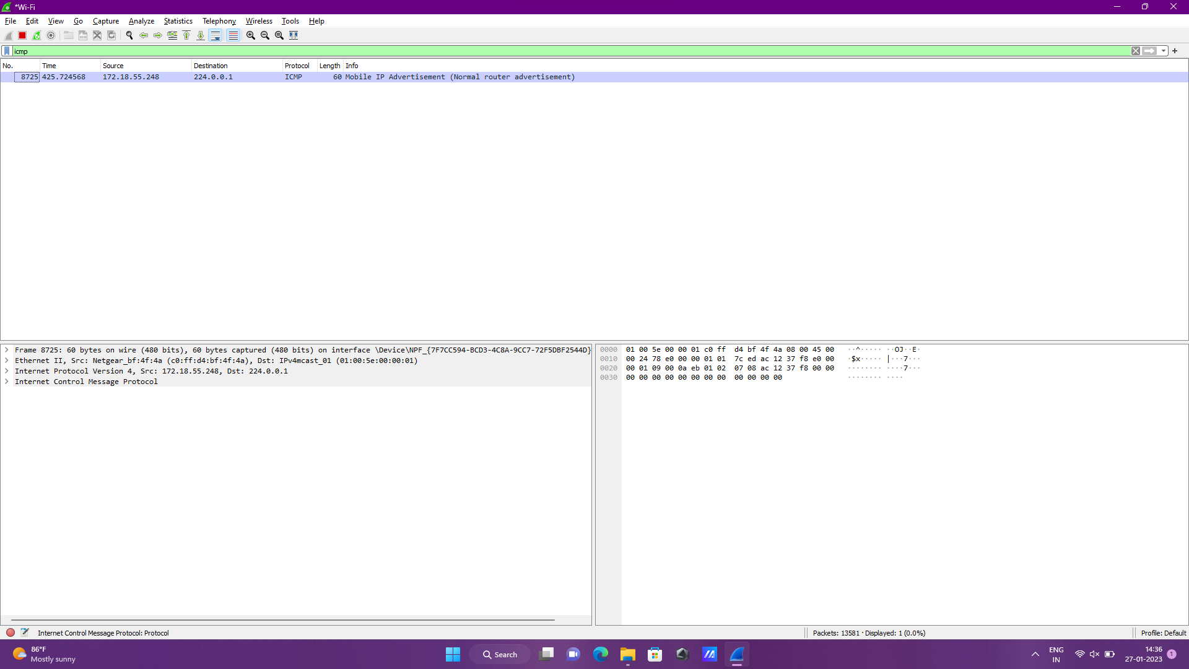

26) Transport layer protocol header analysis using Wireshark - UDP

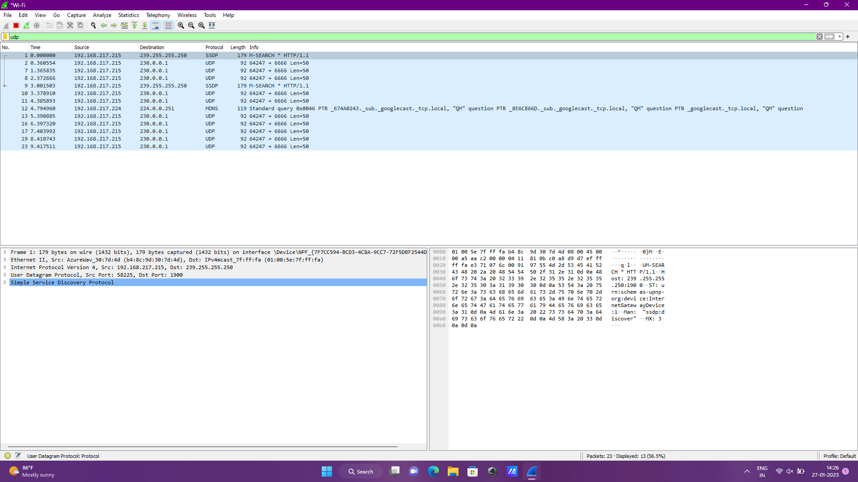

27) Network layer protocol header analysis using Wireshark - ARP

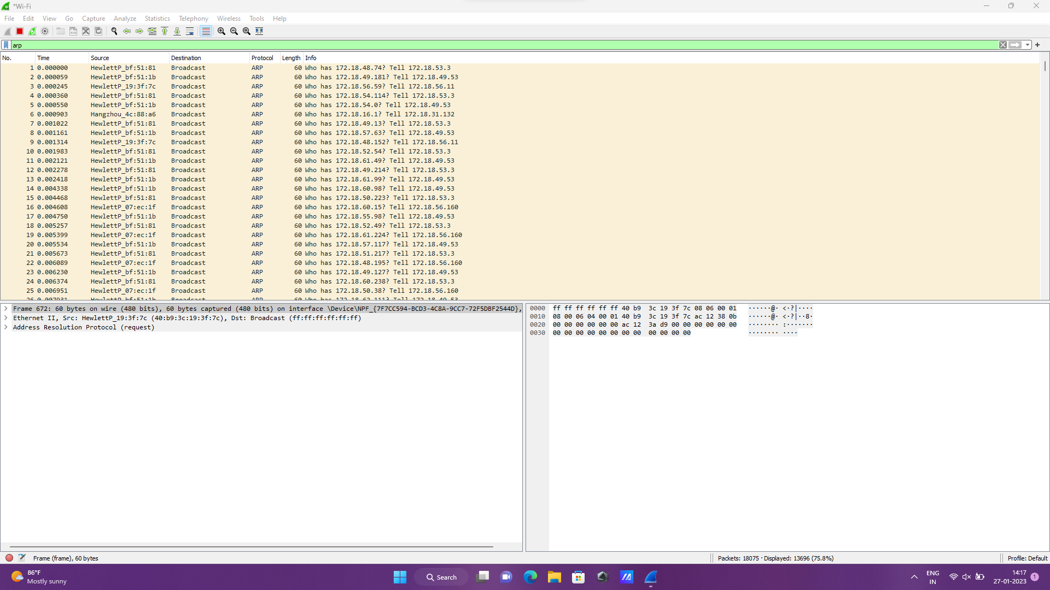

28) Network layer protocol header analysis using Wireshark - HTTP

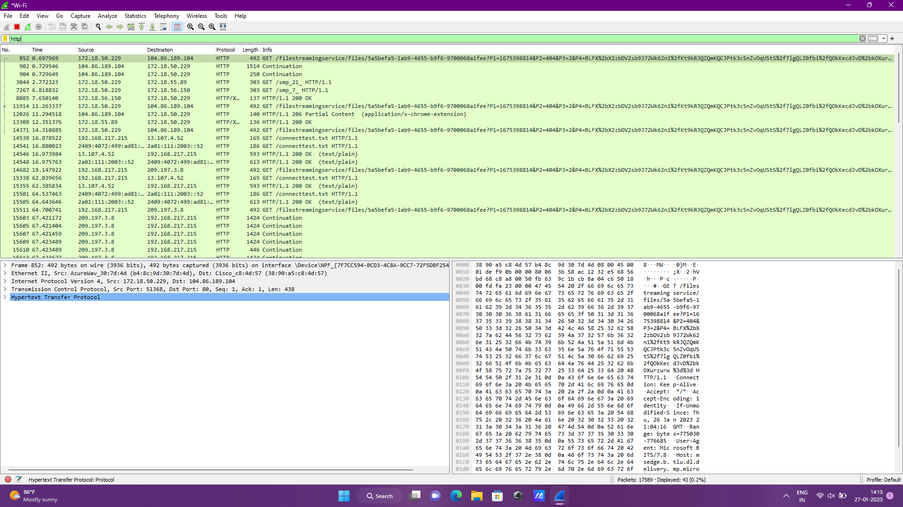

Experiment IOT for smart home control using smartphone

